a/A W1D4 HW

HTML/CSS

-HTML is structure and CSS is styling

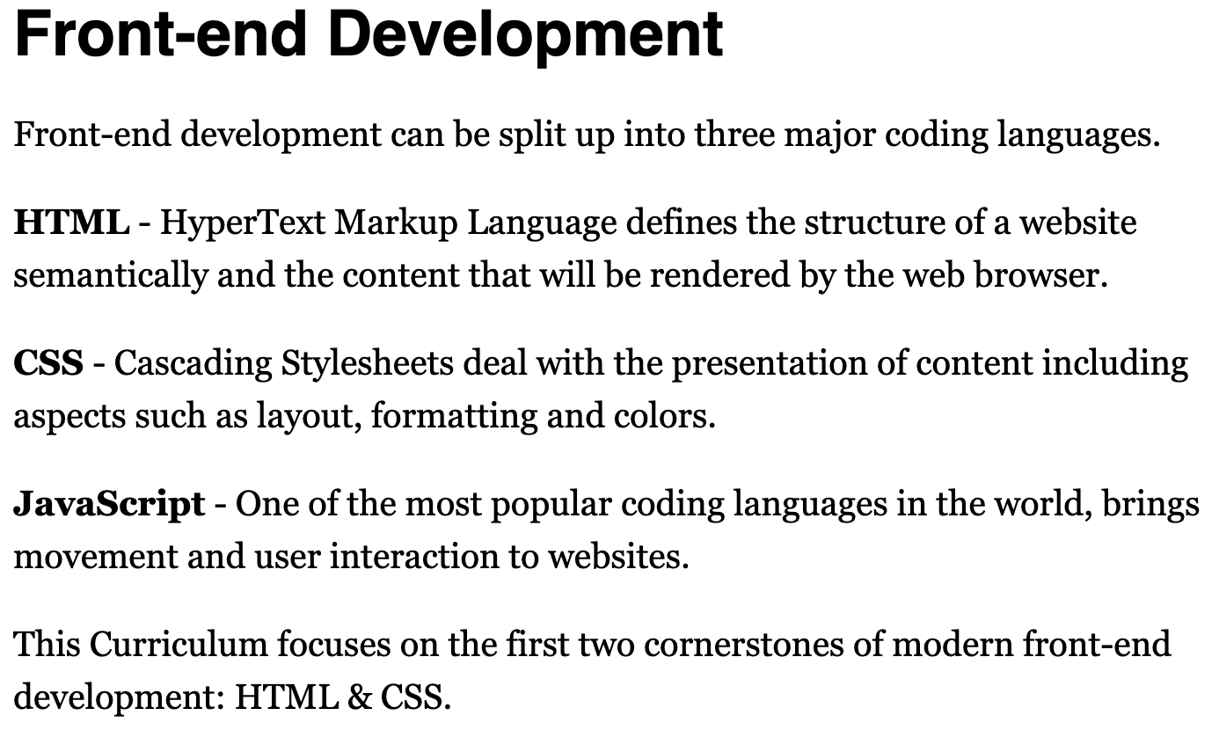

-wrap the elements in <p></p> tags (like <p>element</p>) to make it an HMTL Element

-<img/> can go at the end it wraps an object so it becomes an HTML Element

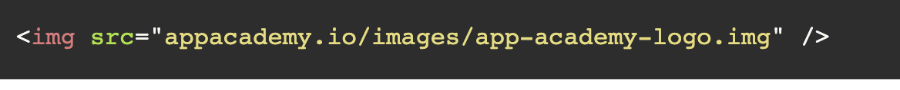

<p>element</p> is for paragraphs

<h1>element </h1> refers to the headers of website

<ul>

<li>element</li>

<li>element</li>

</ul>

For unordered lists, use ul, but for ordered lists, use ol

You can also use <d1> for definition data and term elements

This is an how you tag a link

A hashtag at the beginning of a url tells the browser to look for a attribute with that name

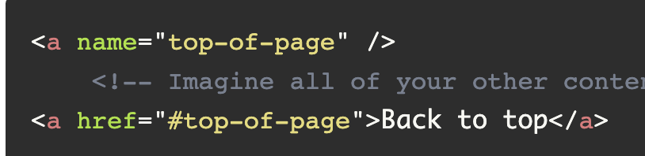

To tag an image, <img src=”link” alt = ”laymen’s terms for link” />

With HTML: think in boxes

Containers are HTML Elements that simply hold other HTML Elements

Below are common tags used for container HTML Elements

